DAY 3 - MINIKUBE TASK

Minikube start and run the following commands , and install Kubernetes and check the version

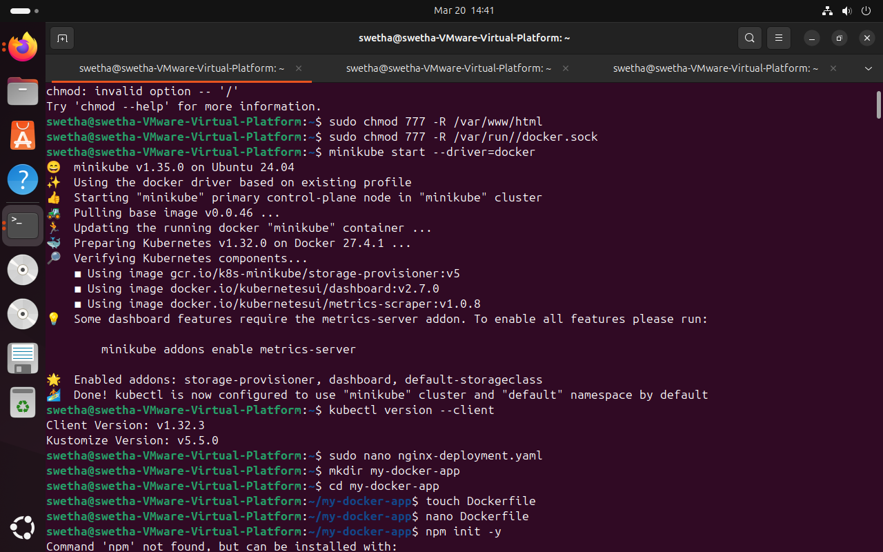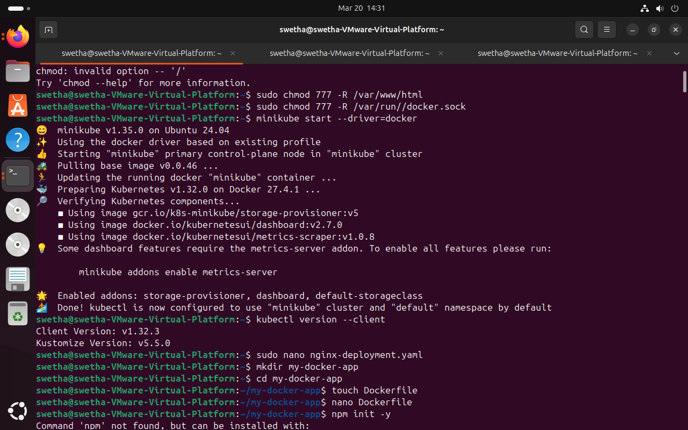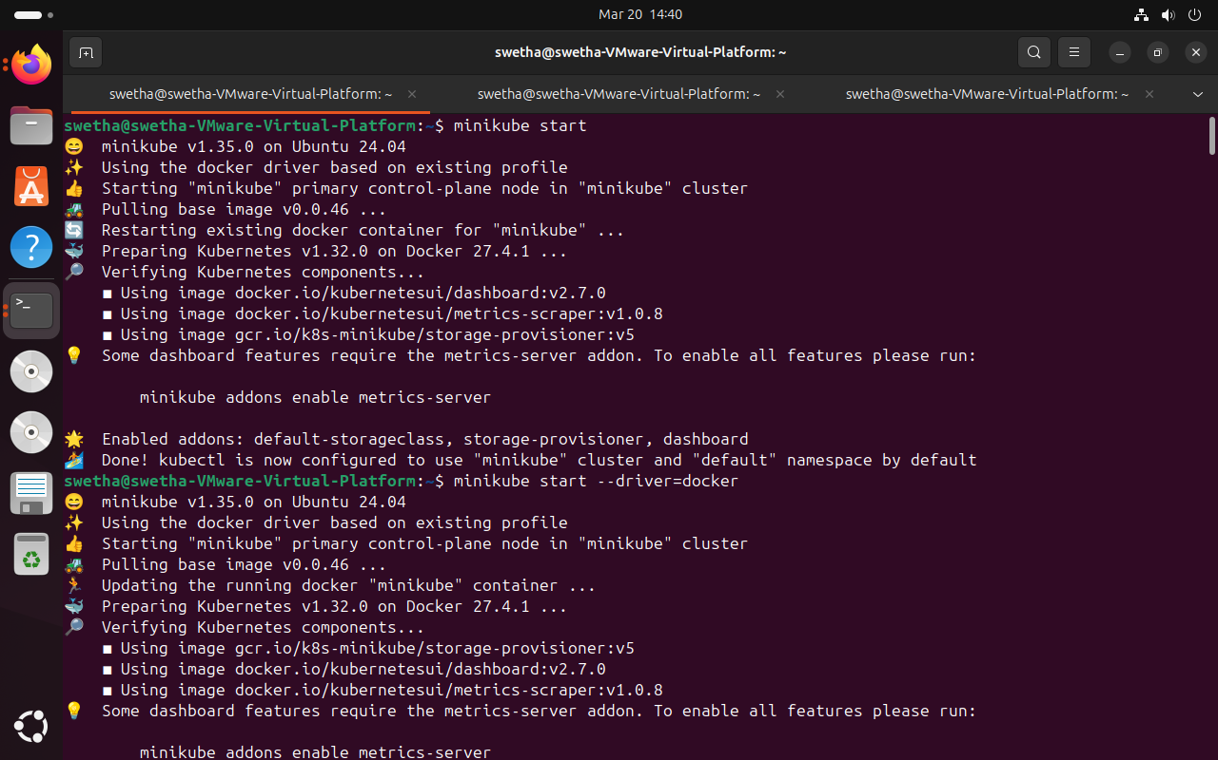

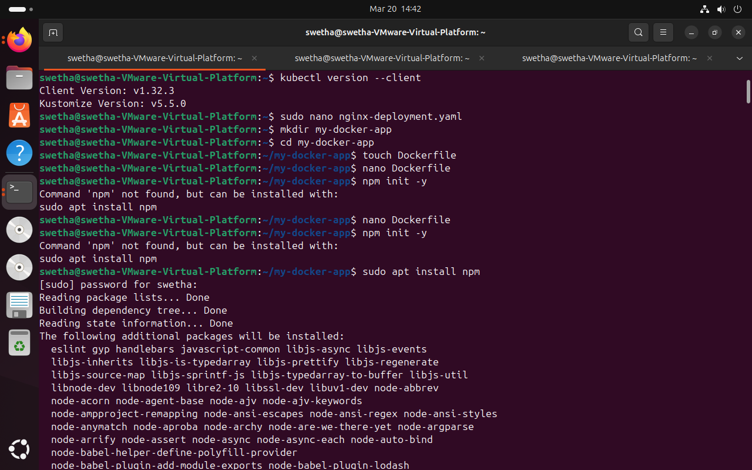

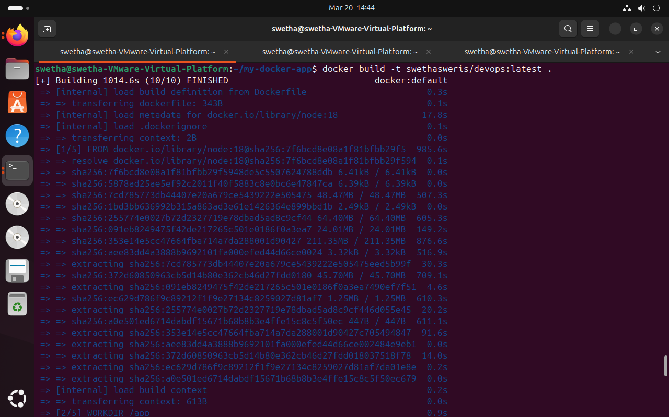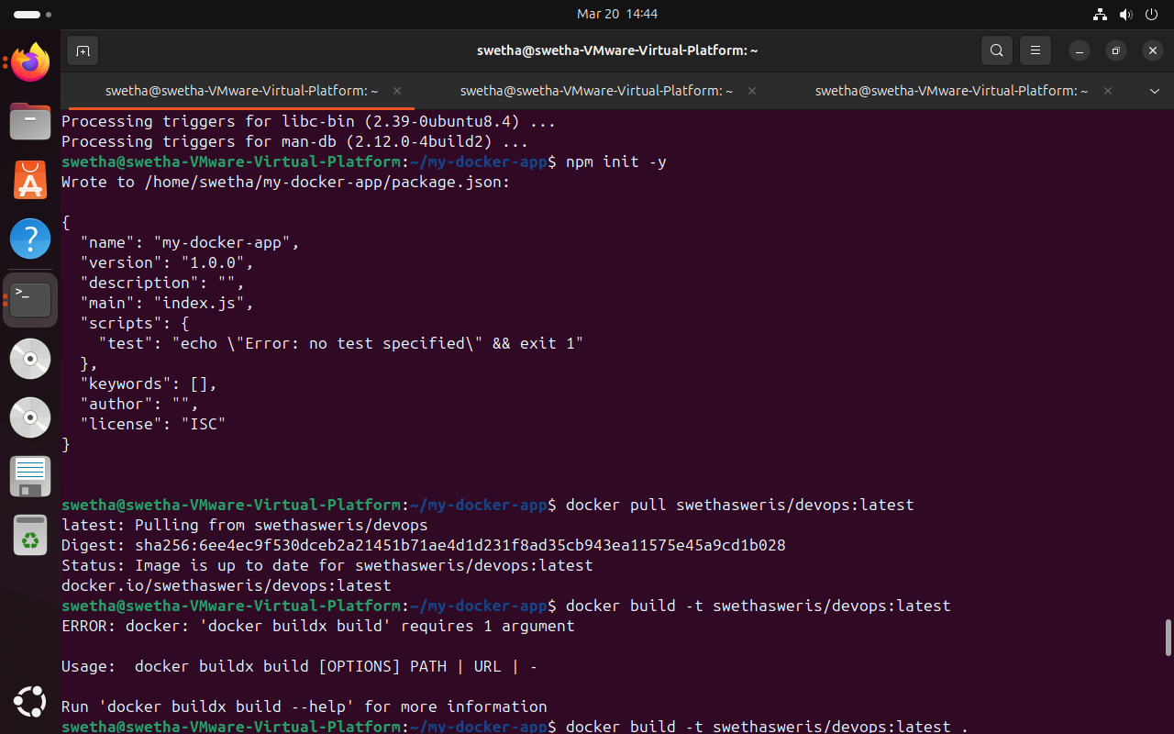

npm init -y

And start pulling and building the docker

Check for docker ps

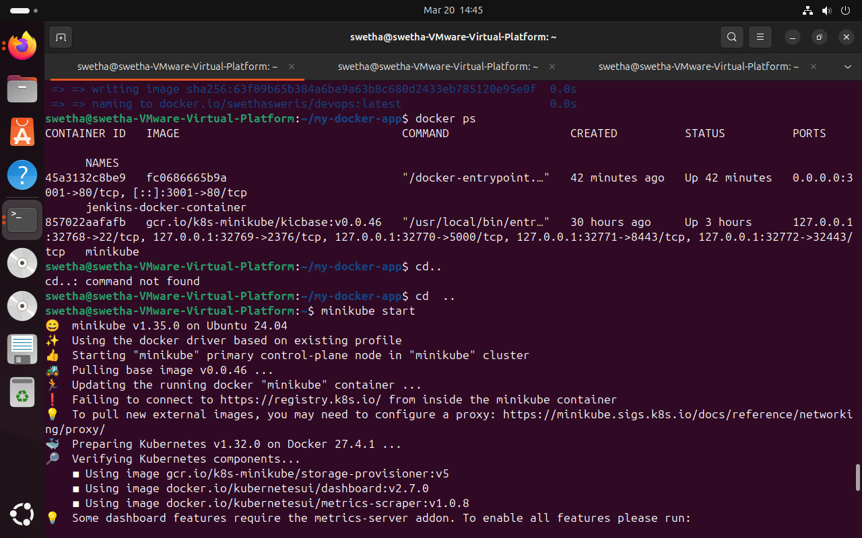

Sudo nano nginx-deployment.yaml

Sudo nano service.yaml

Kubectl apply -f nginx-deployment.yaml

Kubectl apply -f service.yaml

Kubectl get pods

Minikube service my-nginx --url

A url will be generated , copy the url

Minikube tunnel in a new terminal

Curl and then the http

Localhost:ip address has the desired output

